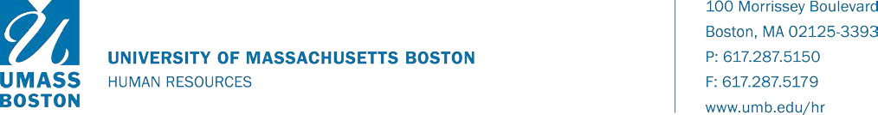

To: The University Community
From: Marie Bowen, Vice Chancellor for Human Resources Date: May 18, 2021
Re: Legal Holidays Observed and Campus Closures for 2021 and 2022
Following is a list of dates on which UMass Boston will be closed in calendar years 2021 and 2022

Legal Holiday | 2021 | 2022
New Year’s Day | January 1 | January 1*
Martin Luther King, Jr. Birthday | January 18 | January 17
Presidents’ Day | February 15 | February 21
Patriots’ Day | April 19 | April 18
Memorial Day | May 31 | May 30
Juneteenth  Independence Day | June 19*  July 4** | June 19**  July 4
Independence Day | July 4** | July 4
Labor Day | September 6 | September 5
Columbus Day | October 11 | October 10
Veterans’ Day | November 11 | November 11
Thanksgiving Day | November 25 | November 24
Christmas Day | December 25* | December 25**
Campus Closure*** | December 29, 30 | December 29, 30

*Saturday Holidays
Under the provisions of Massachusetts General Laws, Chapter 4, Section 7, Clause Eighteen, legal holidays that fall on a Saturday shall be observed on that day. All offices under the jurisdiction of any department of state government shall be open to the public for business on the Friday proceeding any Saturday holiday. However, as many employees as business needs will allow should be given that Friday off, with the following Monday as an alternative Employees assigned to work shall be compensated as the law and applicable collective bargaining agreements required.

**Sunday Holidays
A legal holiday shall be observed the day following when said holiday shall occur on Sunday (Chapter 4, Section 7, Clause Eighteen).

***Campus Closure
In lieu of two previous holiday closures, the campus will be closed (except for designated essential staff) on the two work (business) days prior to the New Year’s Day holiday. Designated essential staff assigned to work on campus closure days shall be compensated in accordance with the applicable collective bargaining agreement.

