Adding and Deleting Tiles in HR Direct
You can customize what is accessible from your Homepage by adding and deleting tiles.

How to Add a Tile
- Click on the Action List menu icon in the upper right corner.
- Select the Personalize Homepage Menu option from the list.
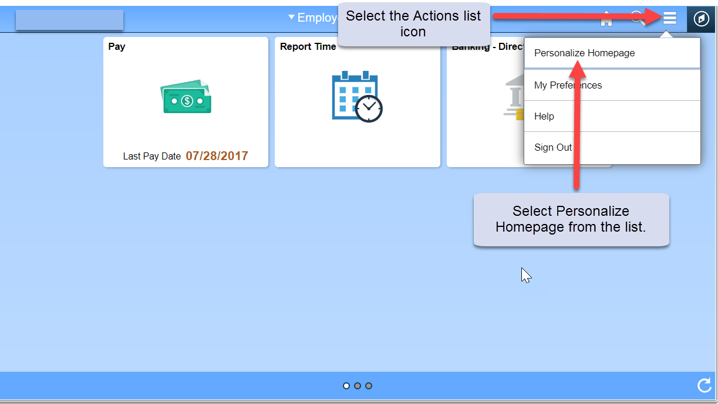

- Click on the “Add Tile” button in the upper right corner. The Add Tile pop-up window is displayed.
- The search bar may be used to locate a tile/page or you can navigate to the menu item to be added. Click the Save button in the top right corner to complete or click the Cancel button in the upper left corner to exit the page without saving your changes.
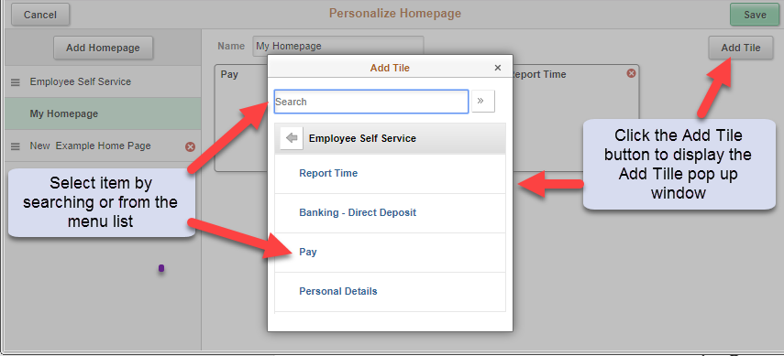

How to Delete a Tile
- Click on the Action List menu icon in the upper right corner.
- Select the Personalize Homepage menu option from the list.
- On the Personalize Homepage, each tile is represented as a square. Click the red ‘X’ in the upper right corner of the tile to be deleted.
- Click the Save button in the upper right corner of the page or click on the Cancel button.
