Personalizing Your Homepage in HR Direct
- Click on the Actions List icon and select Personalize Homepage from the menu.
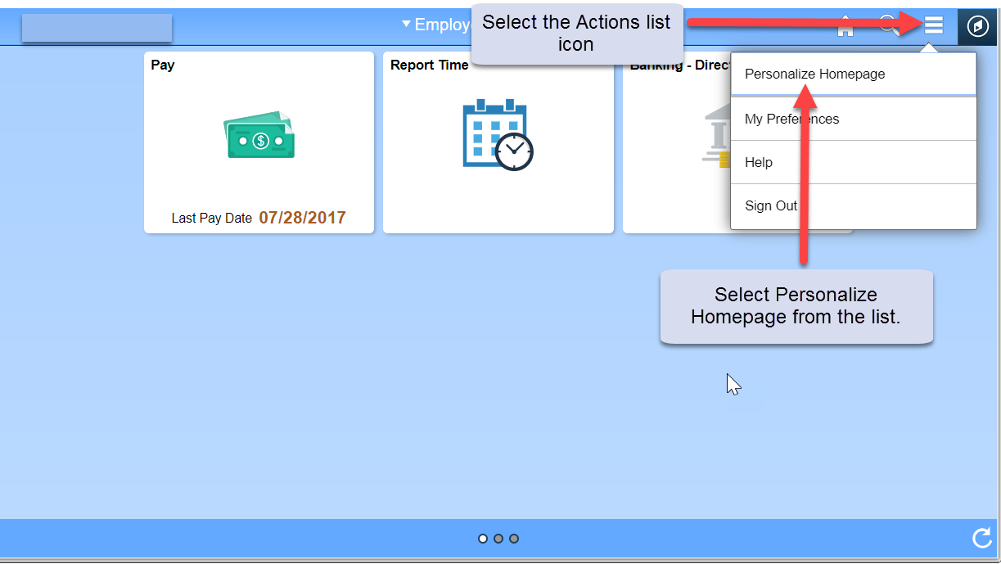
- From the Personalize Homepage screen, click on the Add Homepage button from the side bar on the left. The Add Homepage popup window is displayed.
- Enter the name for your new Homepage then click the Add button in the bottom right corner of the pop-up window.
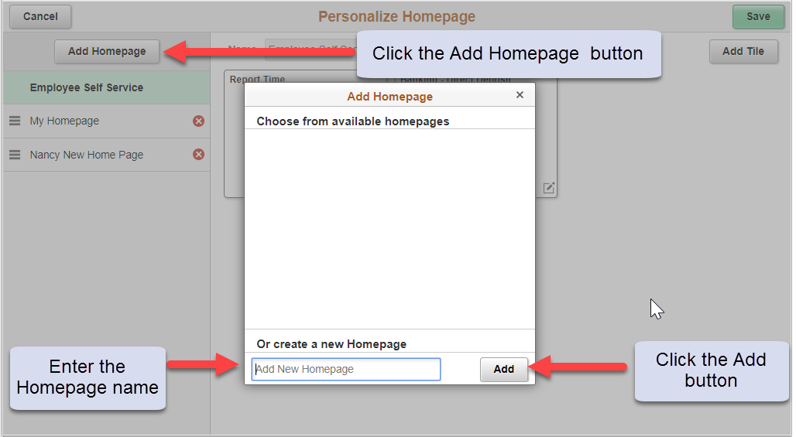

- The new Homepage is available for selection from the left-hand column on the Personalize Homepage screen.

Adding a Tile to Your New Homepage
- Click on the “Add Tile” button in the upper right corner. The Add Tile pop-up window is displayed.
- The search bar may be used to locate a tile/page or you can navigate to the menu item to be added. Click the Save button in the top right corner to complete, or click the Cancel button in the upper left corner to exit the page without saving your changes.
