How to Access Classic mode in HR Direct

To access Classic Mode:
- Click on the NavBar icon in the upper right corner of the page.
- Click on the Classic Home icon from the sidebar menu.
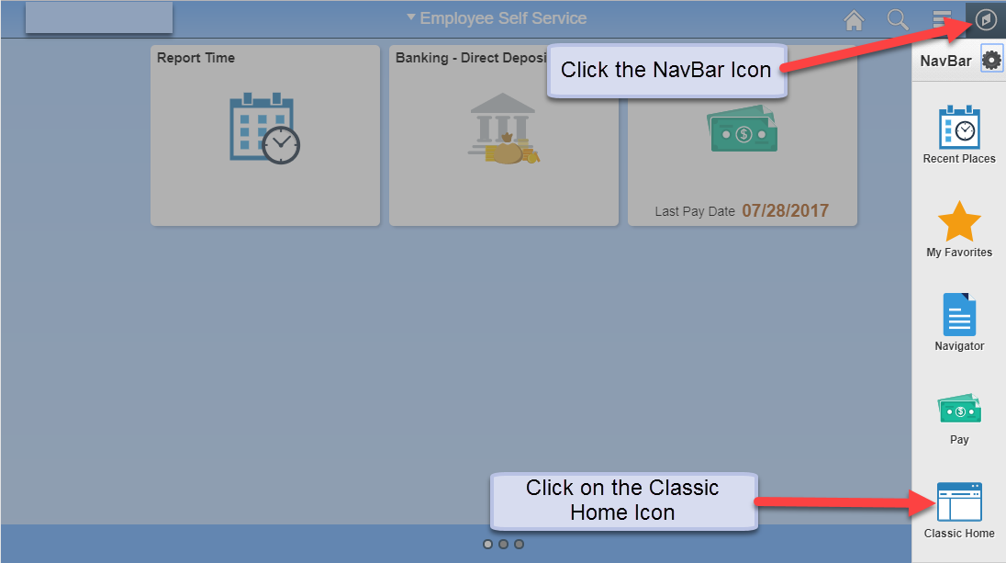

- To add menu options to the Classic Home Page click on Personalize Content in the upper right corner of the page. A pop-up will be displayed.
- Under PeopleSoft Applications, click one of the following checkboxes: Menu, Menu – Classic, or Main Menu. Click the Save button in the bottom left corner to save your changes.
