Accessibility Settings in HR Direct
Accessibility settings can be modified from either a desktop or a mobile device.

Changing Accessibility Settings
- Click on the Action List icon in the upper right corner.
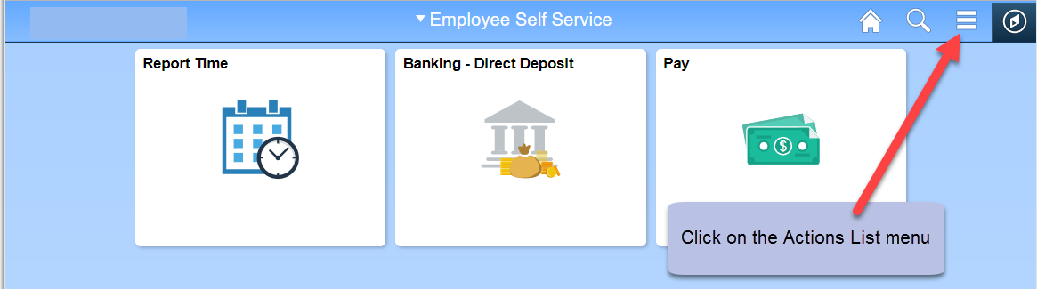
- Select the My Preferences menu option from the list.
- Select the accessibility setting from the Accessibility Features drop down menu.
- Click the Save button in the top right corner to save the settings.

