Process Steps
The instructions below provide steps for running the Time and Attendance report which shows payable time for individual employees within a specified date range.

Step 1 - Navigate to HR Direct.
Step 2 - Select the "Log in to HR Direct Button".
Step 3 - Enter your user id and password.

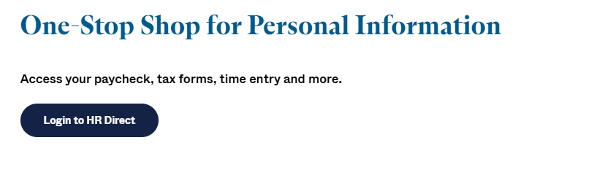
Step 4 - When prompted to sign in to a campus, select "Boston".
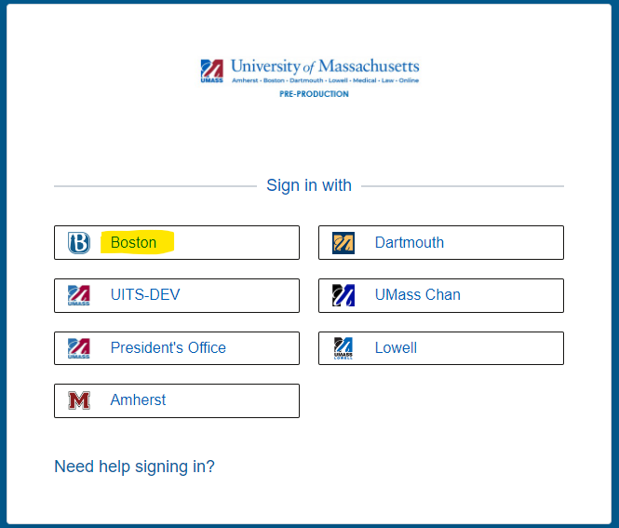

Step 5 – Select the “NavBar” icon in the top right of the screen.
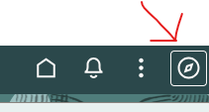

Step 6 – Navigate to “UMass Custom>Time and Labor>Reports>TL Detail Report”.
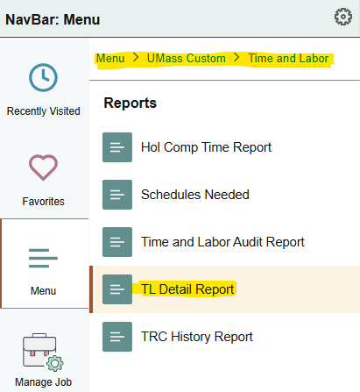

Step 7 – If you have not created a run control to run the “Time and Attendance Report”, select the “Add a New Value” button on the TL Detail Report screen.
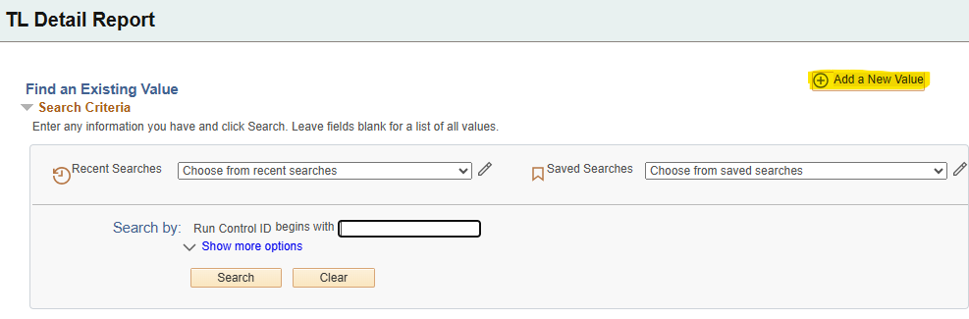
Step 8 – Give the run control a name (no spaces) which you will remember is for running the time and attendance report. Click the “Add” button.

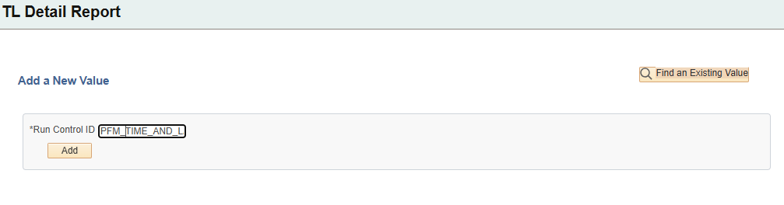

Step 9 – If you have already defined a run control for the “Time and Attendance Report”, hit the “Search” button and select the name of the run control you previously defined.

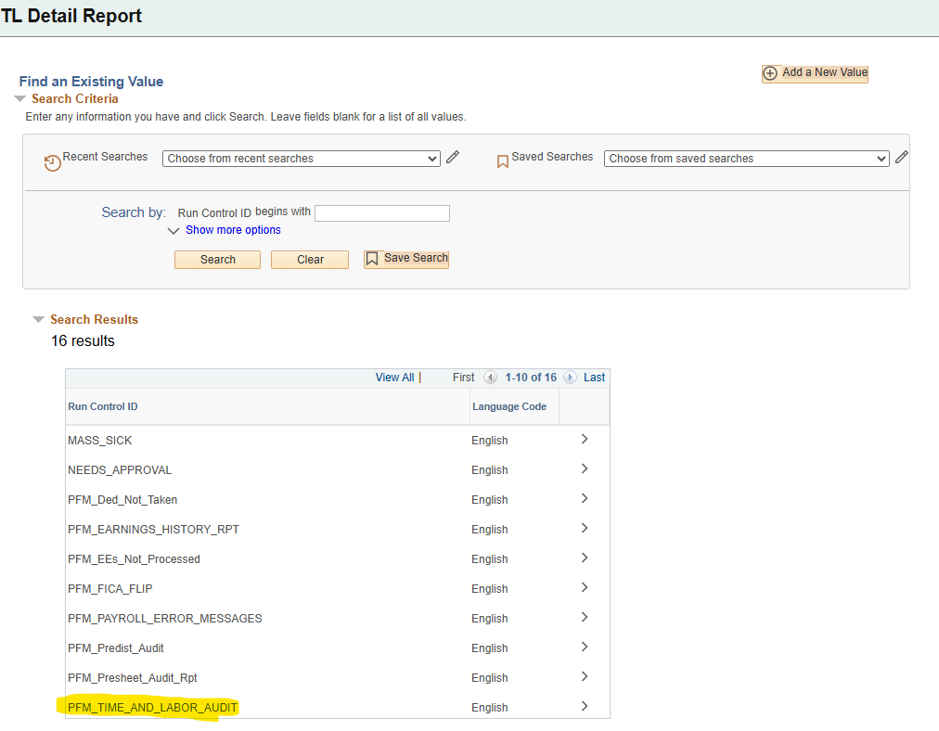

Step 10 – In the “Report Select Criteria” area, click the down arrow next to the “Time Type” field and select “Payable Time”. Click the down arrow next to “Report Type” and select “All Active Employees.” Enter the “Pay Period End Date” or the “From Date” (pay period begin date) and “Thru Date” (pay period begin date) in the fields provided. In the Group/Employee Information area, enter the Employee ID in the “Empl ID” field. Be sure to enter the appropriate record number in the “Rcd Nbr” field. You may add additional rows or subtract rows using the plus and minus signs provided. Hit the “Save” button. Hit the “Run” button to run the report.

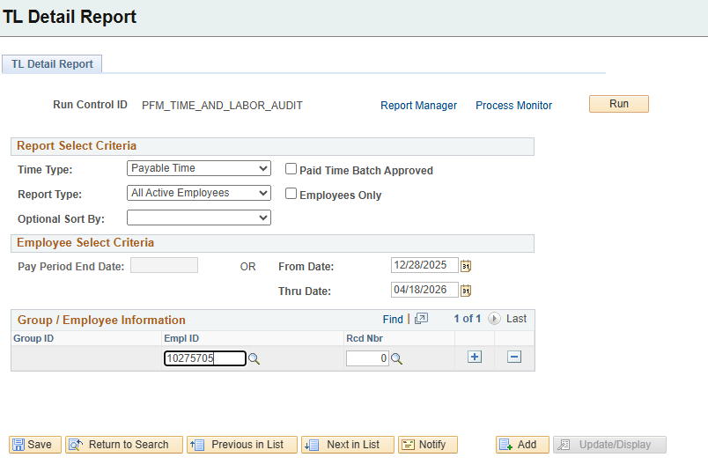

Step 11 – After hitting the “Run” button, a “Process Schedule Request” screen will appear. Under the “Type” column, hit the down arrow to select “Web.” Under the “Format” column, hit the down arrow to select “PDF.” Hit the “OK” button.

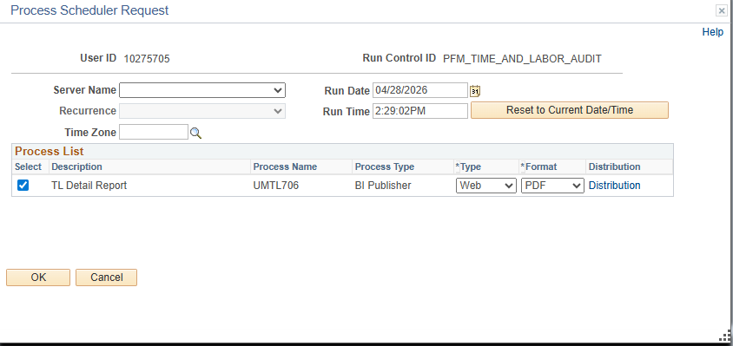
Step 12 – From the “TL Detail Report” screen, click on the “Report Manager” link.

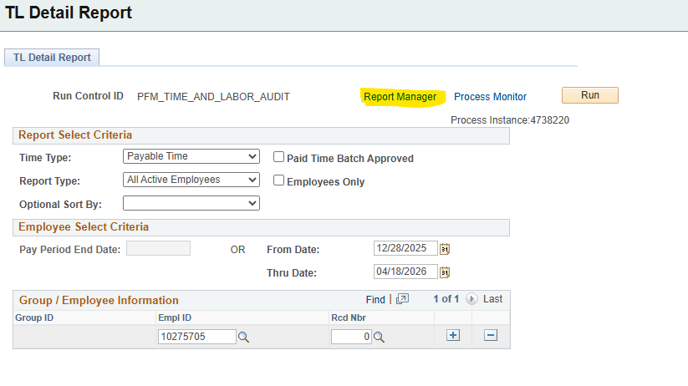

Step 13 – Within the “Report Manager” screen, click the “Administration” tab. The name of the report should show as “UMTL706 – UMTL706 TL Detail Report.pdf”. If the status column does not say “Posted,” keep hitting the “Refresh” button until it does. Once the Status says “Posted,” you can click on the report name link to access the contents of the report.

